Crystal Graph Convolutional Neural Network (CGCNN)-Based Prediction of Electronic, Thermodynamic, and Mechanical Properties for Lithium-Sulfur Battery Cathode Screening
ªMuhammad Amarus Salam, ª*Mauludi Ariesto Pamungkas, ^{b}Muhammad Hilmy Alfaruqi
[a] Department of Physics, Universitas Brawijaya, Malang, Indonesia
*E-mail: m_ariesto@ub.ac.id
[b] Department of Materials Science and Engineering, Chonnam National University, Gwangju 61186,
Korea
Abstract:
Lithium-sulfur batteries (LiSB) are one of the most promising next-generation energy storage technologies because they offer high specific capacity and energy density. However, several challenges face the implementation of LiSB: the low conductivity of sulfur, volume expansion of the cathode during charge-discharge cycling, and the polysulfide shuttle phenomenon. Therefore, cathode host materials are needed to possess high electrical conductivity, thermodynamic stability, and mechanical robustness. Material properties can be calculated using Density Functional Theory (DFT). Unfortunately, DFT calculations are time-consuming and computationally expensive. Thus, in this study, a Crystal Graph Convolutional Neural Network (CGCNN) model was used to predict four properties: band gap, formation energy, bulk modulus, and shear modulus using the JARVIS-DFT database. The model evaluation results for every property show good performance with R² values of 0.9976 for band gap, 0.9965 for formation energy, 0.9890 for bulk modulus, and 0.9823 for shear modulus. For material screening, a Triply Periodic Minimal Surface (TPMS), particularly the Gyroid structure, was used, achieving the highest suitability score of 0.68. Owing to its suitability score for properties, the gyroid structure is the most promising Cathode for LiSB. These results indicate that CGCNN can efficiently screen cathode host materials for LiSB.
Keywords:
Lithium-sulfur batteries; CGCNN, Cathode host materials; Materials Screening; TPMS

1. Introduction
  - Background of Lithium-Sulfur Batteries (
Lithium-ion batteries (LiBs) are the main technology, especially in the energy storage market for portable electronics and electric vehicle applications, because of their high efficiency, long cycle life, and well-developed manufacturing methods. However, electric vehicle applications, coupled with the expansion of large-scale renewable energy systems, are urgently needed and increasing rapidly [1]. Among the most promising options for next-generation energy storage are lithium-sulfur batteries (LiSBs), because they achieve a high theoretical specific capacity of 1675 mAh g⁻¹ and a theoretical energy density of 2600 Wh kg-1, figures that surpass those of conventional lithium-ion batteries [2], [3], [4], [5]. Also, sulfur is abundant and usually found in volcanic mountains, has a lower cost than the cathode materials in LiBs, and is environmentally benign. These factors make LiSB a sustainable alternative for energy storage [6], [7]. The comparison and motivation between LiSB and LiB as an alternative for the next energy storage is illustrated in Figure 1
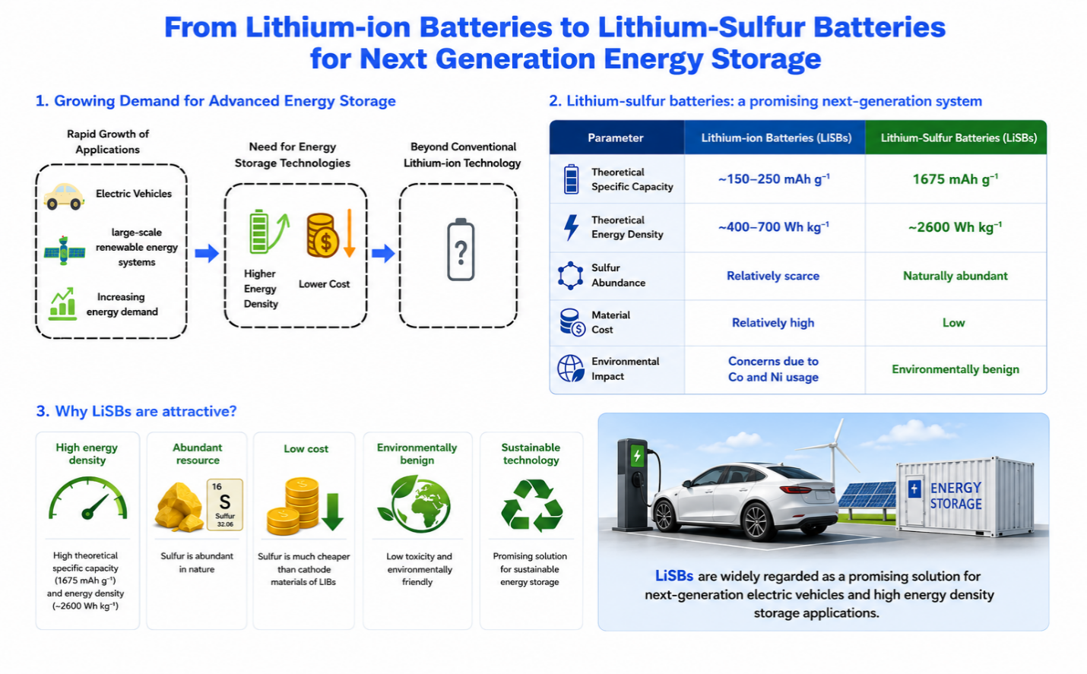
Figure 1 Comparison between lithium-sulfur and lithium-ion batteries
  - The Main Issues of Lithium-Sulfur Batteries
Even though LiSB has excellent theoretical performance, its practical implementation is still hampered by several fundamental issues as illustrated in Figure 2. Sulfur is a non-metallic material that has low electrical conductivity, which limits charge transfer and obstructs electrochemical reactions. Furthermore, the final product of LiSB, which is Li₂S, has volume expansion (80%) during charge and discharge cycles. Therefore, the cathode structure becomes unstable and degrades the electrochemical performance of LiSB [6], [7], [8]. The main critical issue of LiSB is the polysulfide shuttle effect [9]. The Polysulfide shuttle is the process of dissolution and migration of lithium polysulfides (Li₂S_{X}, 4 ≤X ≤8 ) as intermediate species from the sulfur cathode to the lithium anode through the electrolyte. This process produces the loss of active material, low Coulombic efficiency, self-discharge, and rapid battery capacity degradation. In general, the shuttle effect proceeds through several stages: the formation of long-chain polysulfides, their release from the sulfur host, dissolution into the electrolyte, migration to the lithium anode, and leading to the formation of parasitic reactions on the anode surface [5], [8], [10]. Operando visualization studies have also confirmed the dynamic transport of dissolved polysulfides during charge-discharge cycling as well as its direct link to capacity degradation and lithium dendrite formation in the anode battery [11], [12], [13]. Many mitigation strategies, such as electrode modification, electrolyte engineering, and separator design, have been developed to restrain polysulfide diffusion and increase the reversibility of the sulfur redox reaction [14]. Overall, these issues affect the cycling and long-term stability of LiSBs and remain the main obstacles to their practical application and LiSB commercialization on a large scale. Hence, much research is focusing on developing cathode structures and host materials to increase electrical conductivity, accommodate volume expansion, and effectively inhibit the diffusion of lithium polysulfide species [14].
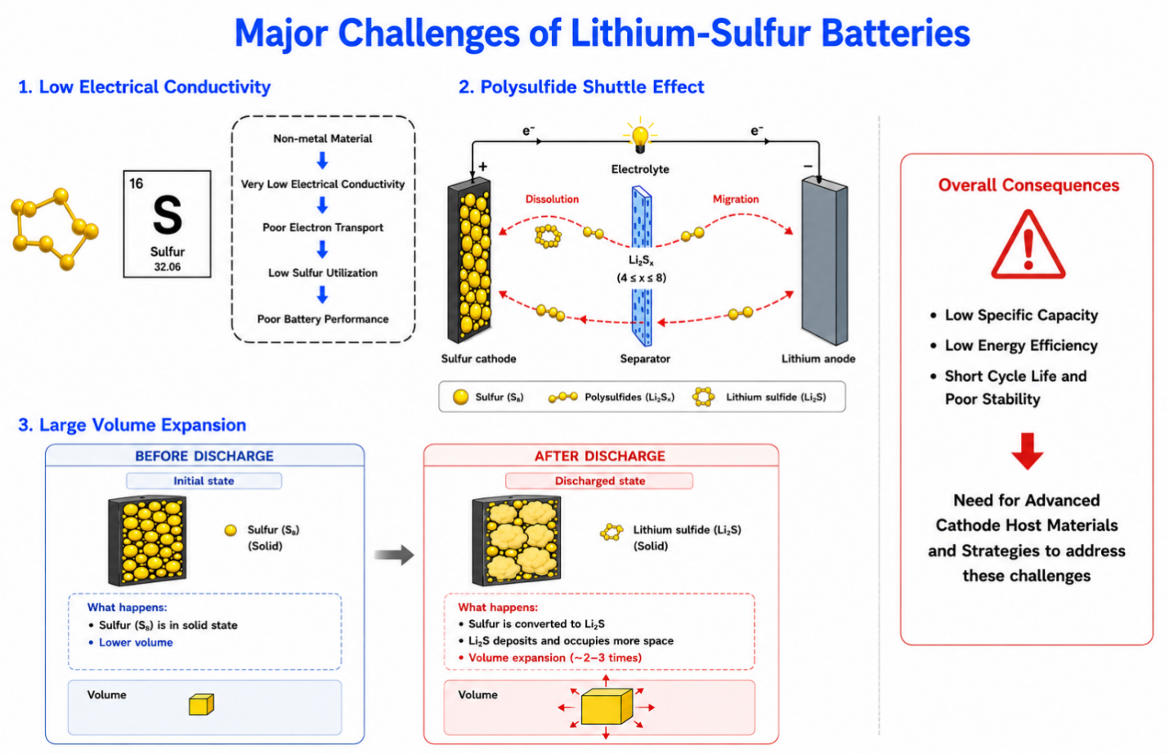

Figure 2 The main issues of Lithium-sulfur battery

  - Cathode Host Materials for Li-S Batteries
To address these issues, intensive research has been conducted to develop the cathode host materials for LiSBs. Various conductive host materials have been developed, such as porous carbon, nanotube carbon (CNT), graphene-based materials, metal oxides, metal sulfides, MXene, and metal-organic frameworks (MOFs) materials to solve the low conductivity of sulfur and its discharge products. Thus, these materials address electron transport, sulfur utilization, and physical confinement for the lithium polysulfide problem [15], [16], [17], [18], [19]. Furthermore, many host materials have strong chemical interactions with the polysulfide species that suppress their dissolution and migration during the cycling process [10].
The cathode host materials performance is determined by their characteristic, such as electronic, thermodynamic, and mechanical properties [2], [7], [8], [20], [21]. Among these, band gaps represent the electronic properties that determine electron transport and sulfur redox reaction kinetics during battery cycling [2], [22]. The thermodynamic stability of the materials is represented by formation energy, where lower values of formation energy show higher stability of materials [23]. The critical parameters for assessing a material’s ability to withstand compressive and shear stresses are represented by bulk and shear modulus. These properties are key to solving the significant volume changes during the lithiation and delithiation processes. Beyond these intrinsic properties, the important factor in determining the electrochemical performance of LiSB are the interaction between the cathode host and the lithium polysulfide species. This interaction can be evaluated by binding energy, which describes the energetic strength of the interaction between polysulfide species and the host material. The more negative values of binding energy indicates a stronger and more favorable interaction, reflecting a higher chemical affinity of the host toward Li. Therefore, binding energy give an information that complementary data about electronic, thermodynamic, and mechanical properties by evaluating the interaction between lithium and the cathode host. A suitable balance between these properties is essential for designing stable host material cathode with electrochemical characteristics beneficial for LiSB. Therefore, the integrity of the structure and long-term band cycling stability problems are solved [17]. However, the combined influence of their electronic, thermodynamic, and mechanical properties is key to the performance of host materials. Thus, a single material is not enough to give a comprehensive evaluation. Therefore, simultaneous evaluation for screening and identifying promising cathode host materials with high conductivity, robust structural stability, and superior mechanical endurance is needed for next-generation LiSB applications.
First-principles calculations using Density Functional Theory (DFT) can predict material properties at the atomic scale [20]. Thus, the target properties of this study can be obtained. However, DFT calculations to predict properties for large material databases are time-consuming and computationally expensive. To overcome these limitations, an efficient approach has emerged for rapidly discovering and screening materials. Machine learning can solve the DFT limitation by learning the relationship between crystal structures and their properties from databases or experimental datasets. With this approach, the screening of vast material candidates can be predicted rapidly before the results are evaluated with DFT, which requires expensive computational resources [24], [25]. Nevertheless, prevailing ML studies predominantly address isolated material properties—separating mechanical metrics from electronic or thermodynamic parameters. Such single-domain models fall short in functional material design, where target candidates must concurrently fulfill electronic, mechanical, and thermodynamic requirements. Here, we present a multi-property ML strategy that concurrently predicts the Band Gap, Formation Energy, Adsorption Energy, Bulk Modulus, and Shear Modulus within a single model architecture. Applied specifically to material interactions with Li₂S in Lithium-Sulfur (Li-S) battery systems, this integrated approach bridges fundamental electronic transport with structural endurance. By co-evaluating adsorption energy to suppress polysulfide dissolution alongside mechanical moduli to endure lithiation-induced mechanical stress, this framework provides a complete toolkit for screening robust, high-performance Li-S battery materials.
In this study, CGCNN was employed to predict the key physicochemical properties of cathode host material candidates, including band gap, formation energy, bulk modulus, and shear modulus. The trained model is subsequently used to accelerate screening of material candidates; thus, the computational cost associated with first-principles calculations is decreased. Furthermore, this strategy can be used to identify potential material cathodes for LiSB, and it is also a more efficient approach than screening that relies entirely on DFT calculations.

2. Computational Methods
2.1 Research Workflow
This study employs a Crystal Graph Convolutional Neural Network to predict various properties of crystalline materials directly from their crystal structures. The main dataset is sourced from the JARVIS-DFT database, used for training and assessing the CGCNN model. Crystallographic information files (CIFs) serve as inputs, which are transformed into crystal graph representations—nodes represent atoms, and edges depict neighboring atomic interactions. The model learns structural and chemical details through convolutional processes. The workflow, illustrated in Figure 3, begins with collecting crystal structures and their properties from the JARVIS-DFT database. These CIFs are converted into crystal graphs, with atoms as nodes and interactions as edges, providing input for the CGCNN to learn directly from the crystal structures..
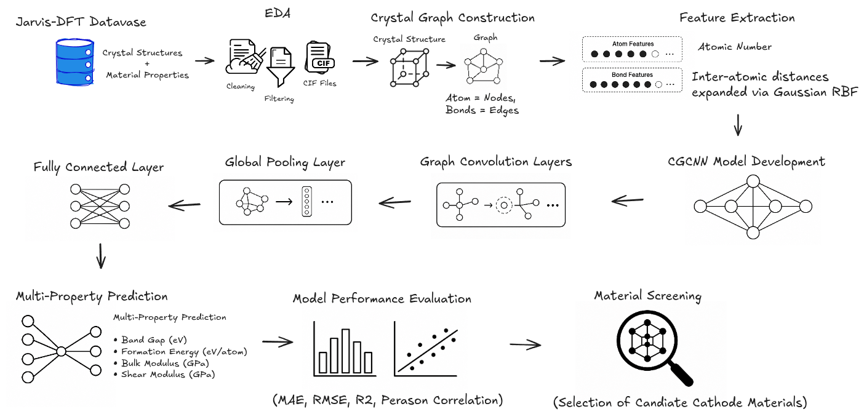
Figure 3. Proposed workflow of the Crystal Graph Convolutional Neural Network (CGCNN) framework for multi-property prediction of crystalline materials.
2.2 Dataset Collection
This dataset was sourced from the Joint Automated Repository for Various Integrated Simulations (JARVIS-DFT), an open-access database offering density functional theory (DFT) calculated properties across numerous crystalline materials. It provides crystallographic data alongside physical and mechanical properties, ideal for developing data-driven models for predicting material properties. The crystallographic information files (CIF) and their associated properties were obtained from JARVIS-DFT. Each CIF details the crystal structure, including lattice parameters, atomic coordinates, atomic species, and symmetry, forming the basis for creating crystal graph representations for the CGCNN model. In this study, four properties—band gap, formation energy per atom, bulk modulus, and shear modulus—were targeted for prediction. To ensure dataset consistency and reliability, only materials with complete crystallographic data and valid values for all targets were kept; samples with missing values were excluded during preprocessing, ensuring each entry is suitable for multi-property prediction.

Table 1 The target property of CGCNN model
Property | Description | Unit
Band Gap | Electronic band gap | eV
Formation Energy | Formation energy per atom | eV/atom
Bulk Modulus | Resistance to uniform compression | GPa
Shear Modulus | Resistance to shear deformation | GPa
2.3 Crystal Graph Construction
Among various ML approaches, graph models can learn from crystalline data. Graph-based models are fit to represent the crystal structure in mathematical expressions [26]. Types of graph-based models that can learn from crystal structure data include the Crystal Graph Convolutional Neural Network (CGCNN), where nodes represent atoms and interatomic interactions or neighbor relationships are represented as edges. Crystal Graph Convolutional Neural Networks are designed to learn structural and compositional information from crystal graph representations. CGCNN also demonstrated promising performance in predicting various material properties. Therefore, integrating CGCNN with material databases will be an efficient strategy for screening potential cathode host materials for LISBs. The graph construction from crystal structure is illustrated in Figure 4 [27].
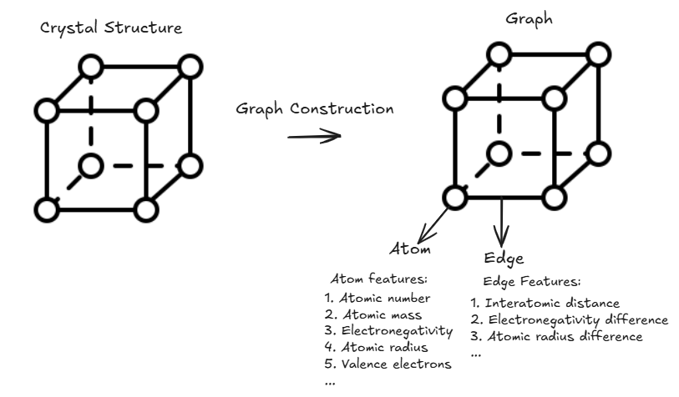
Figure 4. Graph model from crystal structure illustration
In this study, CGCNN was employed to predict the key physicochemical properties of cathode host material candidates, including band gap, formation energy, bulk modulus, and shear modulus. The trained model is subsequently used to accelerate screening of material candidates; thus, the computational cost associated with first-principles calculations is decreased. Furthermore, this strategy can be used to identify potential material cathodes for LiSB, and it is also a more efficient approach than screening that relies entirely on DFT calculations.
The crystal structures obtained from the JARVIS-DFT database were transformed into graph representations following the Crystal Graph Convolutional Neural Network (CGCNN) framework. Unlike conventional machine learning approaches that rely on handcrafted descriptors, CGCNN directly utilizes the crystal structures to learn the relationship between atomic arrangements and material properties.
Each crystal structure is modeled as an undirected graph, with nodes (vertices) representing atoms and edges indicating interactions between neighboring atoms. Each node has an atomic feature, while each edge captures the geometric relationship between atoms. This graph reconstruction maintains the crystal's chemical composition and local structure, allowing the neural network to automatically learn relevant structural features. The core convolution operation of CGCNN is illustrated in Equation (1).
$v_{i}^{\left(t+1\right)}=v_{i}^{\left(t\right)}+\sum_{\left(j,k\right)}{σ\left(z_{\left(i,j\right)k}^{\left(t\right)}W_{f}^{\left(t\right)}+b_{f}^{\left(t\right)}\right)⊙g\left(z_{\left(i,j\right)k}^{\left(t\right)}W_{s}^{\left(t\right)}+b_{s}^{\left(t\right)}\right)}$ (1)
Where $v_{i}^{\left(t\right)}$ is the representation of atom (node) $i$ at layer $t$, $v_{i}^{\left(t+1\right)}$, $v_{i}^{\left(t+1\right)}$ is the updated feature of representation of atom $i$ at layer $t+1$, $z_{\left(i,j\right)k}^{\left(t\right)}$ is the combined atom and edge features, $W$is learnable weight matrices, $b$ is bias terms, $σ$ is sigmoid activation function, $g$ is non linear activation function, $⊙$ is element multiplication, $\sum_{\left(j,k\right)}{}$ is the aggregation of information from all neighboring atoms
To construct the crystal graph, neighboring atoms were identified by using the nearest neighbor searching algorithm in Pymatgen library. For every atom, a fixed number of nearest neighboring atoms was selected to ensure a consistent graph topology across different crystal structures. The resulting graph was subsequently used as the input to the CGCNN model for feature learning and multi-property prediction.

2.4 Crystal Graph Convolutional Neural Network
The crystal graphs generated in the previous stage were used as inputs for the Crystal Graph Convolutional Neural Network (CGCNN). The proposed model consists of four main components: an embedding layer, graph convolution layers, a global pooling layer, and fully connected layers. First, the feature space is suitable for representation of each atom by aggregating information from its neighbouring atoms, allowing the model to capture local atomic environments and structural characteristics.
After the convolution process, a global pooling layer combines the atom-level features into a single vector representing the entire crystal. This crystal-level representation is then passed to the fully connected layers, which perform multi-output regression that can predict the band gap, formation energy, bulk modulus, and shear modulus simultaneously.
2.5 Model Training
Before training, the dataset was randomly split into training, validation, and testing subsets in an 80%, 10%, and 10% ratio. The training set was used to optimize the CGCNN model parameters, while the validation set helped tune hyperparameters and monitor convergence. The testing set was kept aside to evaluate the final model's predictive performance. The model was trained with the Adam optimizer and the Smooth L1 loss function, which offers stable optimization and lessens the impact of outliers. During training, the parameters were updated through backpropagation to reduce errors in predicting four target properties. The initial learning rate, batch size, and number of epochs were chosen empirically to maximize prediction accuracy.
2.6 Performance Evaluation
Model performance was evaluated by using four regression metrics: Mean Absolute Error (MAE), Root Mean Square Error (RMSE), coefficient of determination ($R^{2}$), and Pearson correlation coefficient. The expressions of MAE, RMSE, $R^{2}$, and Pearson correlation coefficient are shown in equations 2-4
$MAE=\frac{1}{n}\sum_{i=1}^{n}{\left|y_{i}−\hat{y_{i}}\right|}$ (2)
$RMSE=\sqrt{\frac{1}{n}\sum_{i=1}^{n}{{\left(y_{i}−\hat{y_{i}}\right)}^{2}}}$ (3)
$R^{2}=1−\frac{\sum_{i=1}^{n}{{\left(y_{i}−\hat{y_{i}}\right)}^{2}}}{\sum_{i=1}^{n}{{\left(y_{i}−\overline{y}\right)}^{2}}}$ (4)
where $n$ denotes the total number of samples, $y_{i}$ and $\hat{y_{i}}$represent the actual and predicted values of the $i$-th sample, respectively, while $\overline{y}$ and $\overline{\hat{y}}$ denote the mean values of the actual and predicted data, respectively.
3. Result and Discussion
3.1 Exploratory Data Analysis
Exploratory Data Analysis (EDA) is an important step before training the dataset. EDA is the stage for understanding the characteristic pattern, distribution, and quality of a dataset before it is used for more analysis or machine learning prediction. EDA also helps identify issues with the dataset, such as missing data or invalid data. Therefore, the data can be cleaned and prepared for analysis or machine learning.
3.1.1 Distribution of Target Properties
Figure 5 shows the distribution of each property in the dataset. The band gap distribution is highly right-skewed, indicating that most values are close to 0 eV. The frequency of materials decreases significantly with increasing band gap values. Furthermore, long tails extend to approximately 2.68 eV. This indicates that the original dataset is dominated by materials with low band gap values, which are metallic and semimetallic. This unbalanced data makes the model biased and causes it to learn materials with low band gap values. Consequently, filtering and balancing the data are needed to achieve a more representative distribution of band gap values for training the model. The formation energy distribution shows a unimodal, concentrated profile. The highest frequency in the formation energy distribution is in the negative region and gradually decreases toward more negative and positive values, indicating that negative formation energy values are predominant and providing a relatively concentrated target range for machine learning prediction. The distribution of the mechanical properties, which are bulk and shear moduli, exhibits positive skewness, with most materials concentrated in the low-to-moderate range, indicating that only a small fraction of materials achieve high bulk and shear moduli. These high moduli correspond to the extended right tail of the distribution and to materials with greater resistance to volumetric and shear deformation.
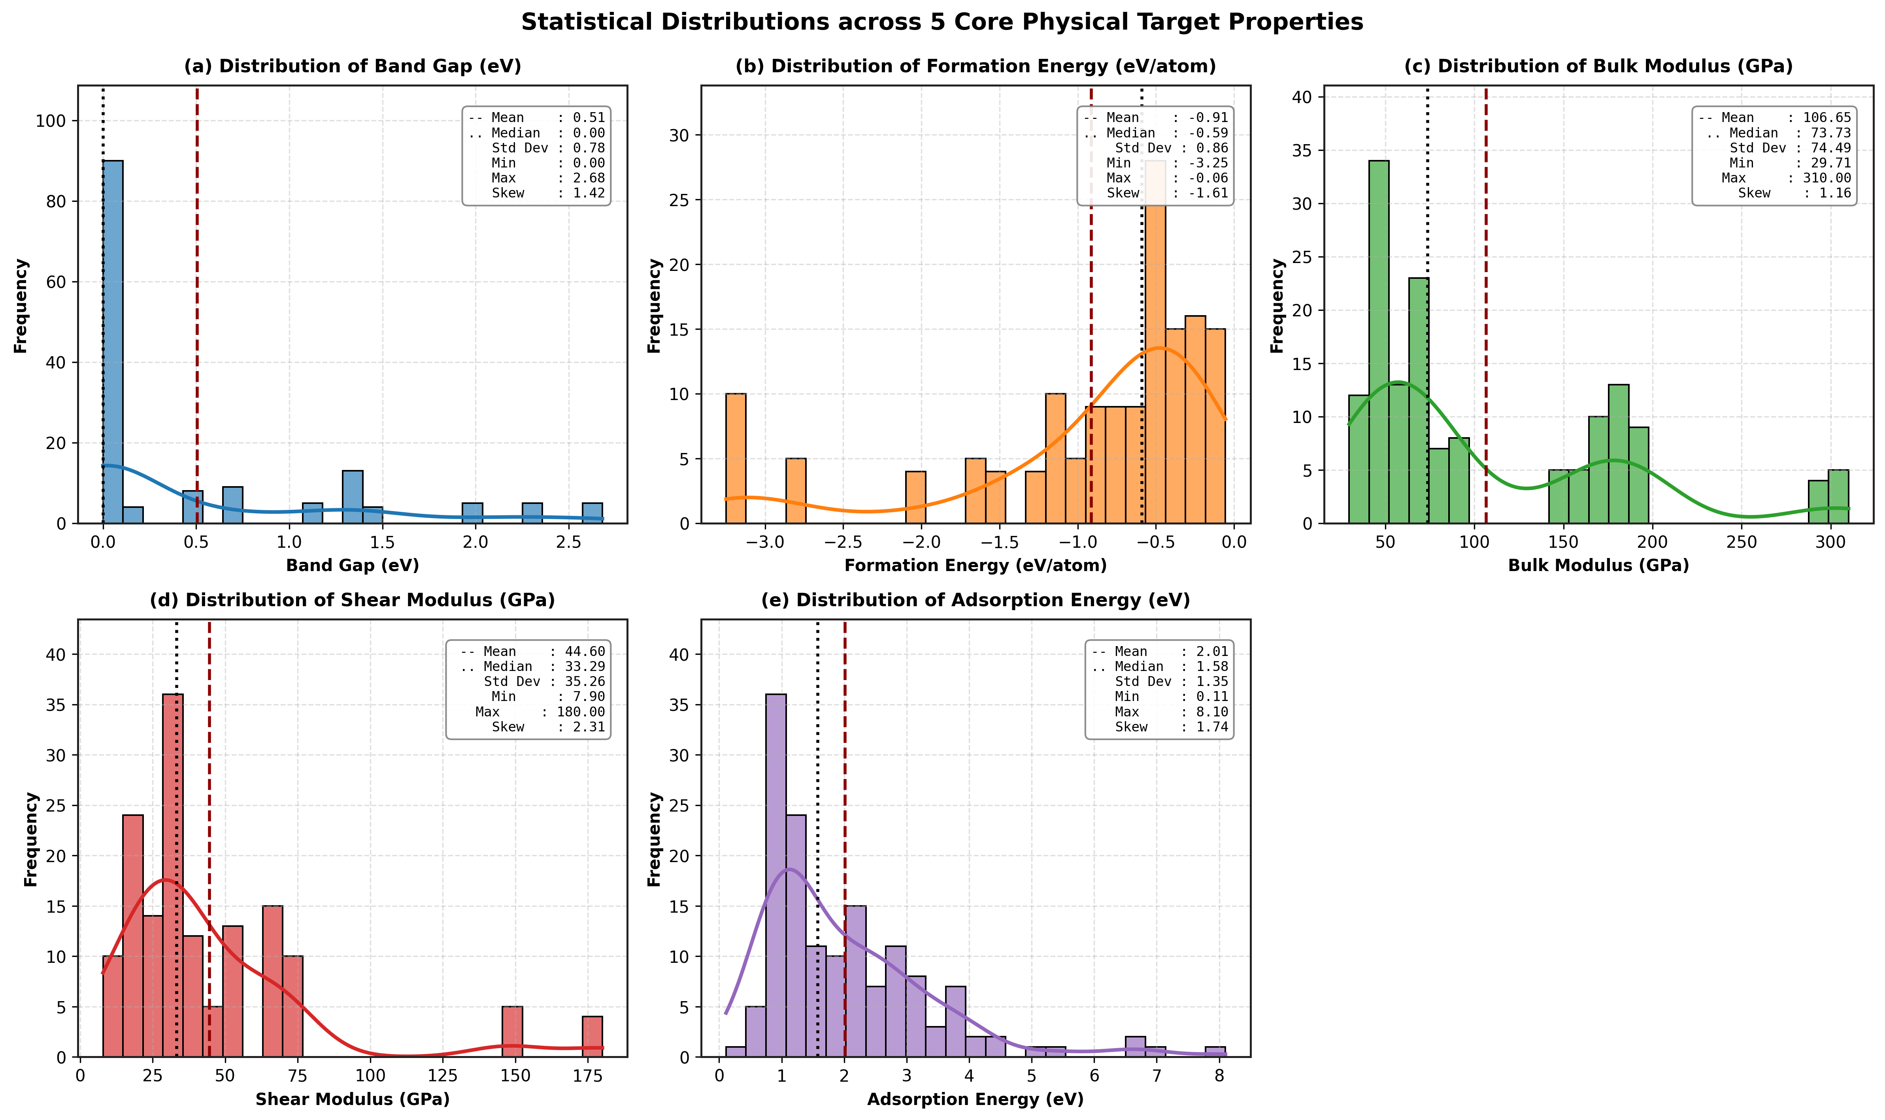
Figure 5 Distribution data of multi-property targets: (a) band gap distribution, (b) formation energy, (c) bulk modulus, (d) shear modulus
3.1.2 Correlation Analysis
Figure 6 illustrates the correlation of each property. The highest correlation (0.86) is shown between the bulk and shear modulus, because both measure the stiffness of the materials. Meanwhile, the band gap and formation energy are moderately negative (-0.64), indicating that materials with the larger band gap are more thermodynamically stable. For the other property pairs, the correlations are weak and near zero, indicating that there is no correlation between the electronic and mechanical properties in this dataset.

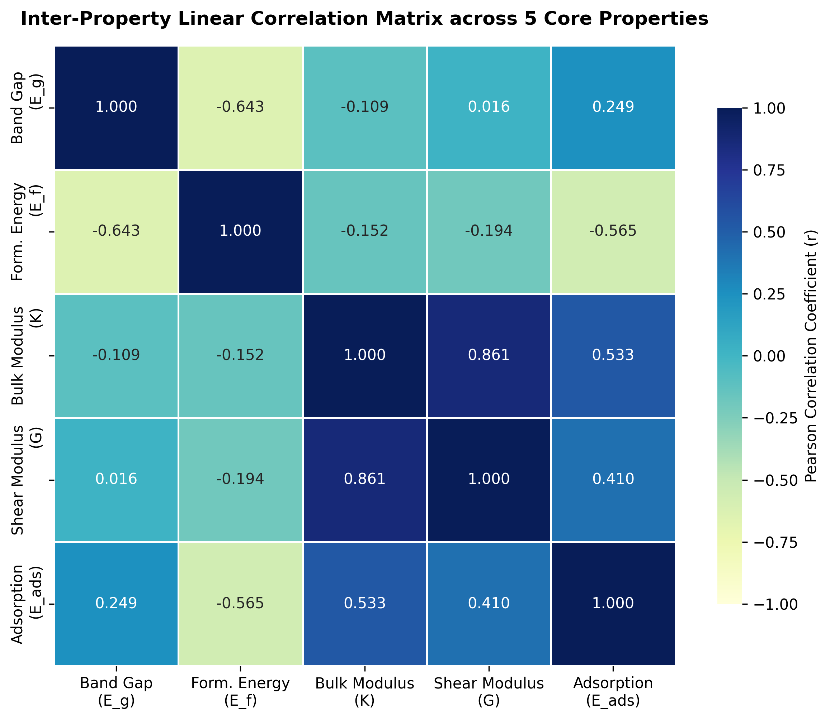
Figure 6 Pearson Correlation for each property

3.1.3 Material Category Distribution
In the dataset, materials were categorized into four categories based on their band gap values: metals, semimetals, semiconductors, and insulators, as presented in Figure 7. The largest proportion is metallic materials, followed by semiconductors and insulators, while the smallest proportion is semimetals. This indicates that the dataset is imbalanced, with metallic materials being the largest category. Despite this imbalance, all categories were included to provide a variety of crystalline materials for training the CGCNN model.
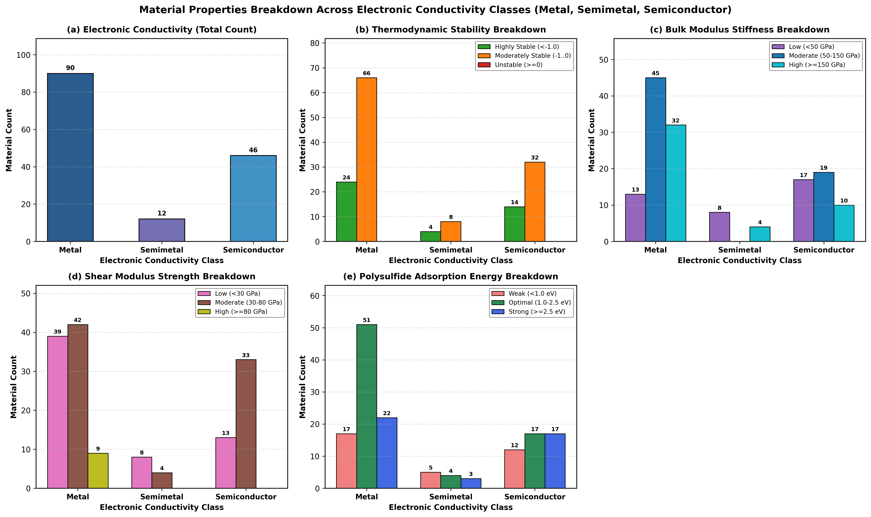
Figure 7 The Quantity of materials and categories based on each property
3.2 Model Performance
This section presents the performance of the CGCNN model for multi-property prediction. Model performance was evaluated using the training process, quantitative metrics, and agreement between predicted and reference values. These analyses provide a comprehensive assessment of the model’s capability to predict electronic, thermodynamic, and mechanical properties of crystalline materials.

3.2.1 Model Training and Convergence Analysis
The CGCNN model training processes are shown in Figure 8. During the initial epochs, the training, validation, and testing loss curves decrease rapidly, indicating that the relationship between crystal structures and the target material properties has been captured. During model training, the loss values gradually stabilize and converge, indicating that the optimization has reached a stable state.
Although the training loss continued to decrease during training, the validation and test losses remained relatively stable, with only minor fluctuations. The small distance between these three curves indicates good generalization and that the model is not overfitting. Overall, this convergence confirms that the CGCNN model can learn features representative of crystals suitable for multi-property prediction.
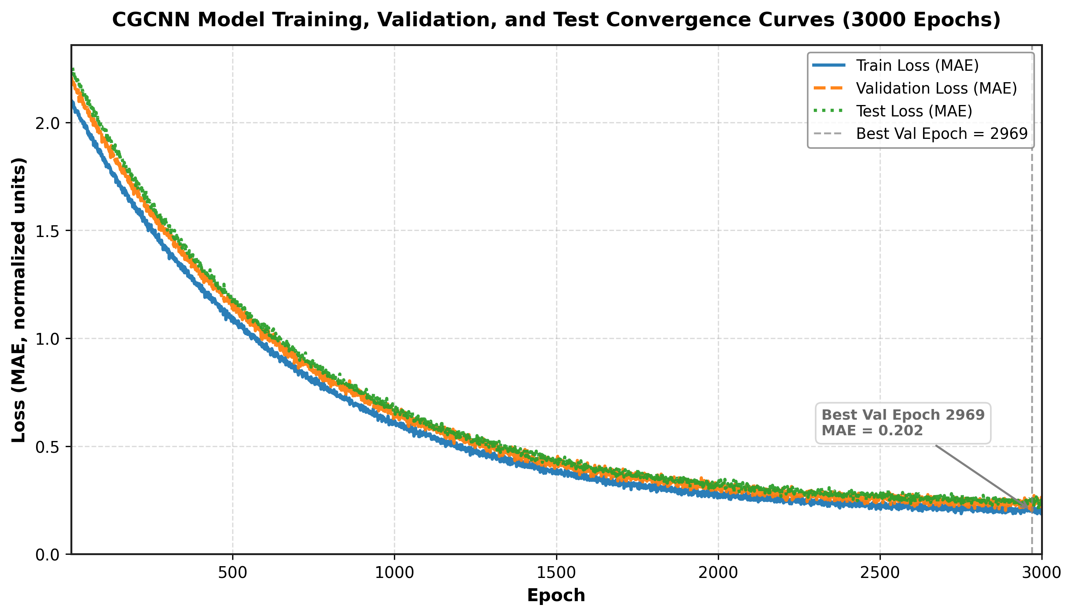
Figure 8 Training, validation, and testing loss curves of the proposed CGCNN model.
3.2.2 Prediction performance analysis
Satisfactory prediction accuracy across all targets has been achieved by the trained CGCNN model. The lowest prediction errors and the highest R² and Pearson correlation values are achieved by band gap. Formation energy and bulk modulus also exhibit strong prediction accuracy, whereas shear modulus produced larger prediction errors. The evaluation results for each target property are summarized in Figure 9.

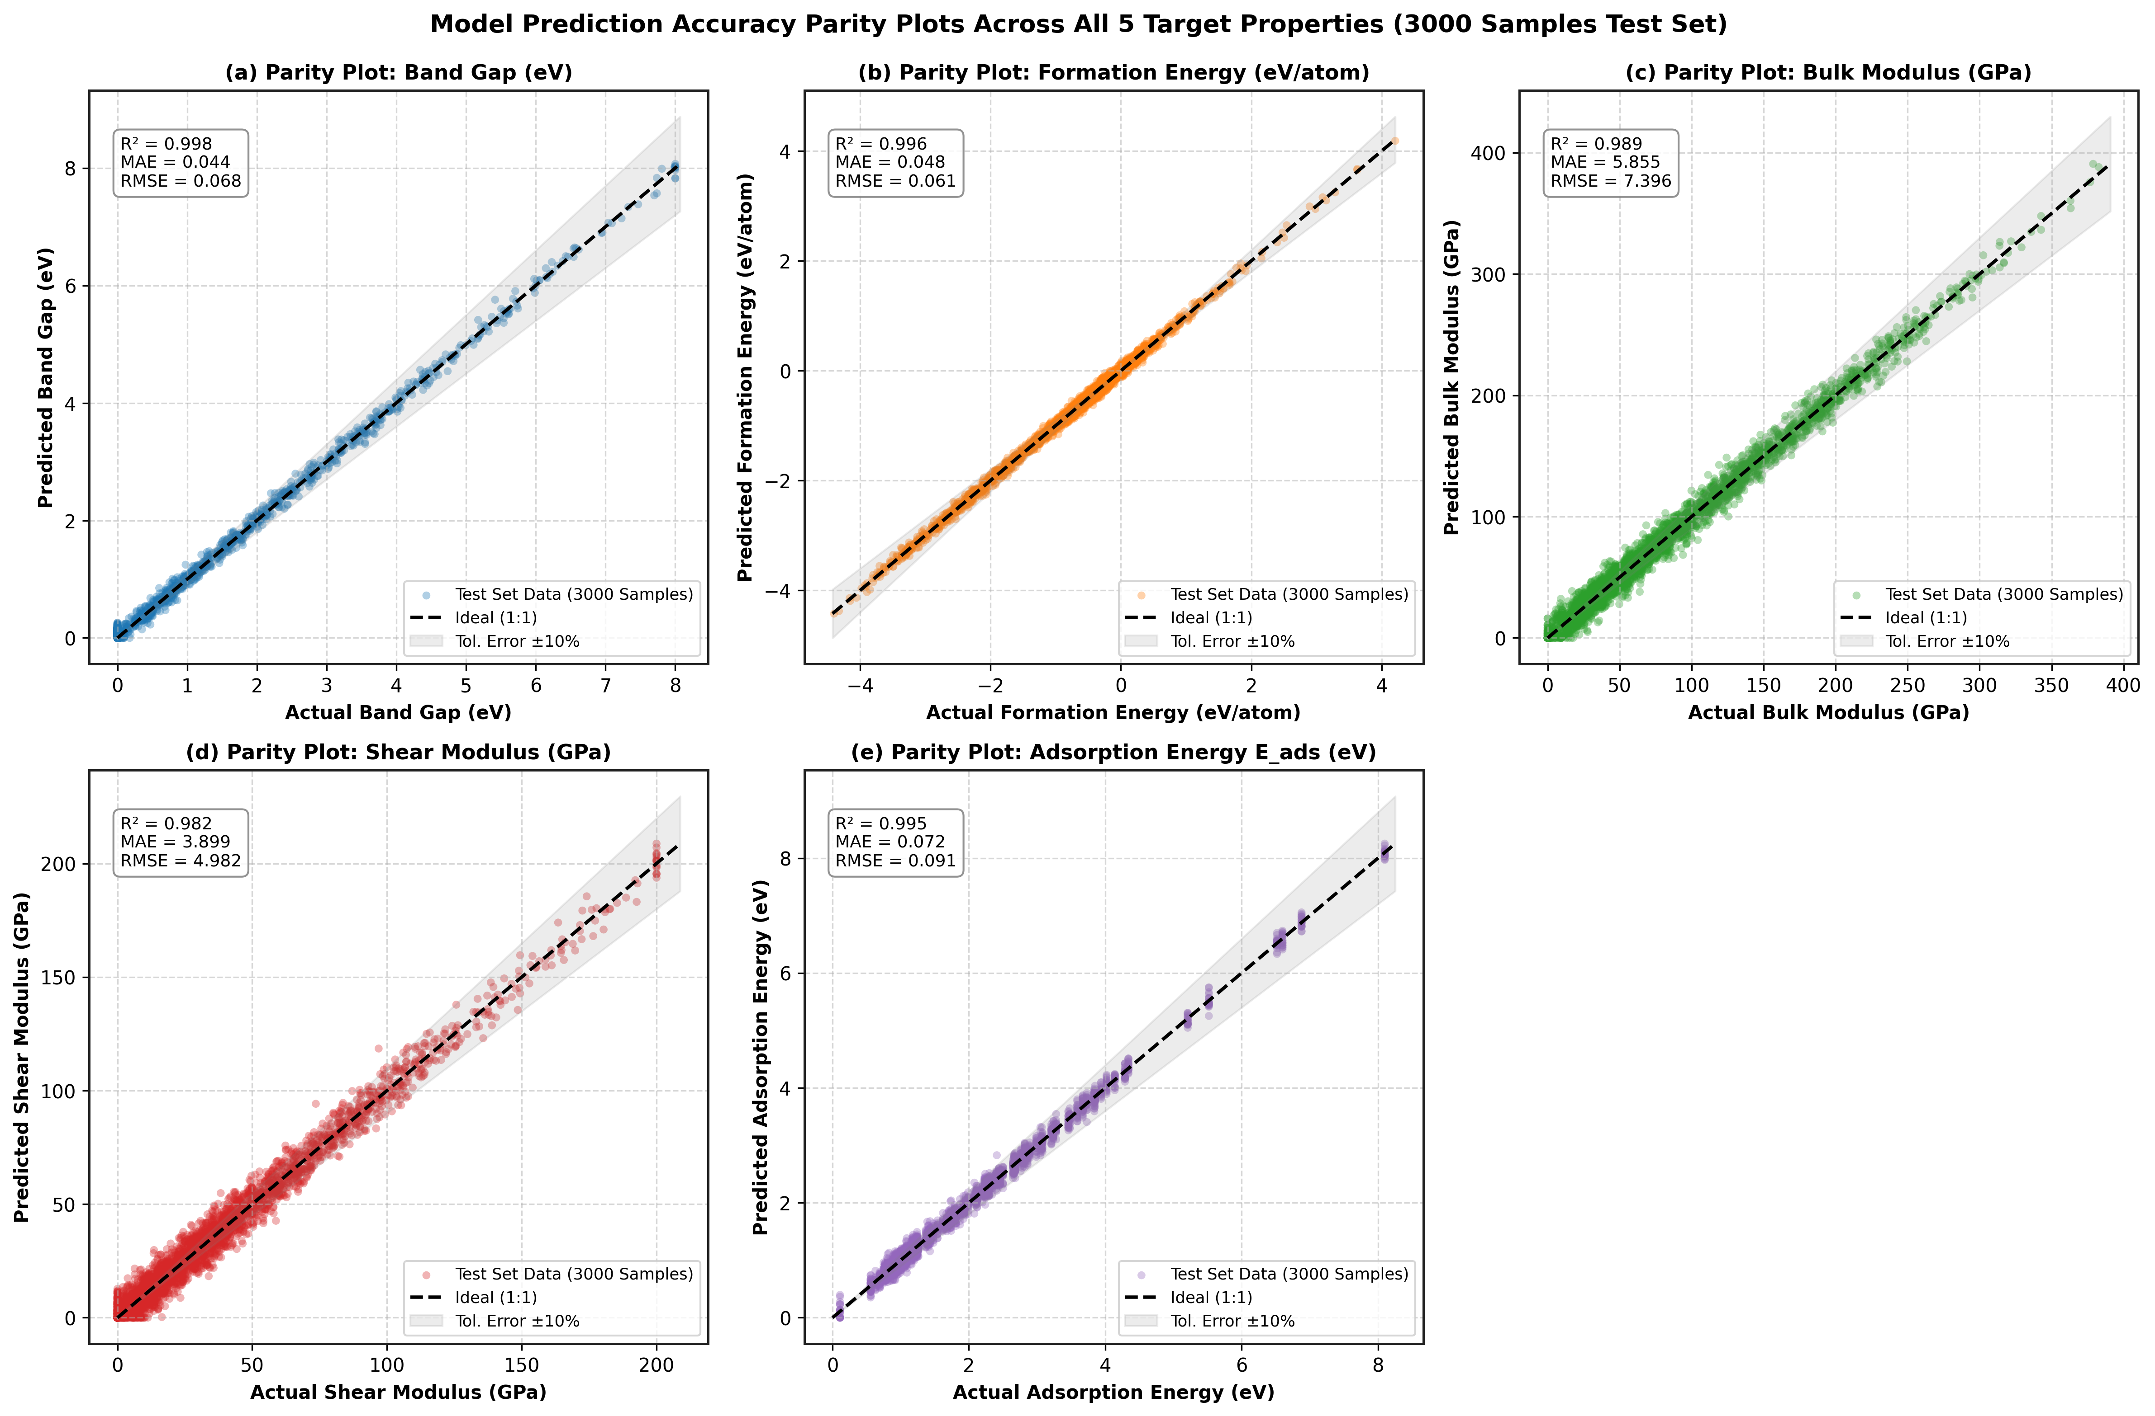

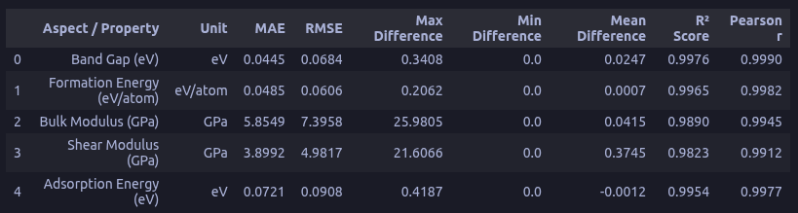
Figure 9 CGCNN model evaluation result
3.2.3 Actual vs Predicted Result Analysis
Figure 10 compares the predicted and actual values. After training, the predicted values align with the diagonal reference line, indicating good agreement between the model predictions and the DFT-calculated values. Band gap shows the closest agreement with the reference values, as reflected in its high R² and Pearson correlation coefficient. Formation energy and bulk modulus also show strong predictive performance, though with a small number of outliers. In comparison, the shear modulus shows a slightly larger spread around the reference line, consistent with the relatively high prediction error in Figure 9. Overall, the CGCNN model provides reliable predictions across different material properties, as shown by the distribution of data points.

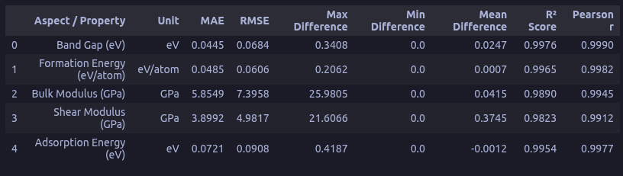
Figure 10 Comparison between the predicted and reference values for the train, validation, and test datasets by their evaluation metrics

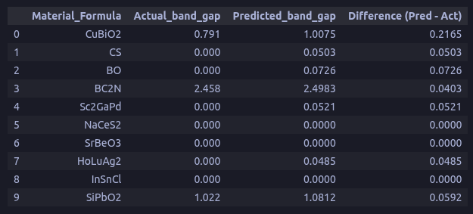
Figure 11 Comparison of actual and predicted band gap values in the test data

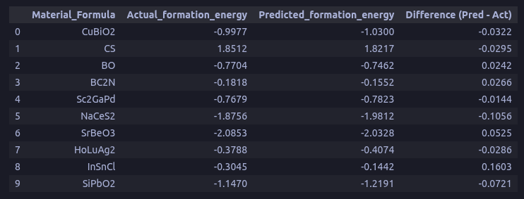
Figure 12 Comparison of actual and predicted formation energy values in the test data

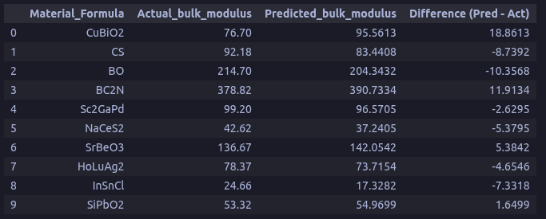

Figure 13 Comparison of actual and predicted bulk modulus values in the test data
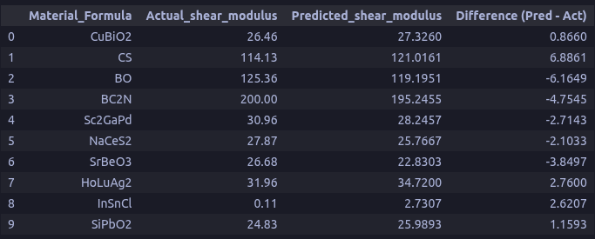
Figure 14 Comparison of actual and predicted shear modulus values in the test data
3.3 Screening of Li-S Cathode Candidate Materials
After training, the model was tested on five TPMS topologies: Primitive, Diamond, Gyroid, IWP, and Neovius. The CGCNN model learns the relationship between structural geometry and material properties, even though all structures share the same composition. The model's generalization capability across different structures, a crucial factor for reliable screening applications such as identifying host material candidates for LiSB cathodes, has been confirmed in these findings. Moreover, the CGCNN framework offers an efficient strategy for accelerating the identification of potential LiSB cathode host materials from large material databases. Thus, extensive first-principles calculations or experimental screening are reduced.
3.4 Discussion of Top Five TPMS Ranked Li-S cathode Host Materials
Following the evaluation of the CGCNN model on the five TPMS-based graphene structures, the results (Figure 15) show that the Gyroid structure achieves the highest suitability score, followed by Neovius (0.60), Diamond (0.55), IWP (0.51), and Primitive (0.40). The scoring was integrated with the predicted values of band gap, formation energy, and bulk and shear moduli. The high score of the Gyroid structure can be attributed to its balanced combination of electronic and mechanical properties, including a low band gap of 0.06 eV, a high bulk modulus of 277.335 GPa, and a high shear modulus of 163.830 GPa. Although Neovius has a lower band gap and higher bulk modulus, its shear modulus is low. Therefore, the Gyroid also provides the most balanced combination of electronic and mechanical properties among the investigated TPMS structures. These results are consistent with previous studies that report the favorable mechanical properties of the Gyroid structure [28], [29], [30]. Furthermore, the predicted band gap is within the range reported in the literature, indicating that the CGCNN model provides a realistic prediction and can also serve as an initial tool for screening material candidates. These results show that the Gyroid is a promising TPMS candidate for cathode LiSB by addressing electrical conductivity and mechanical stability.
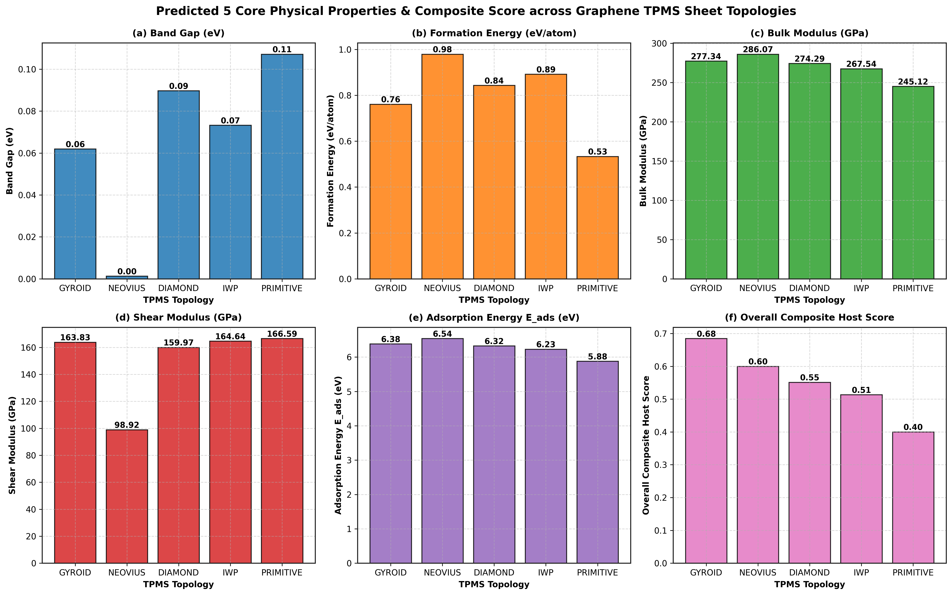
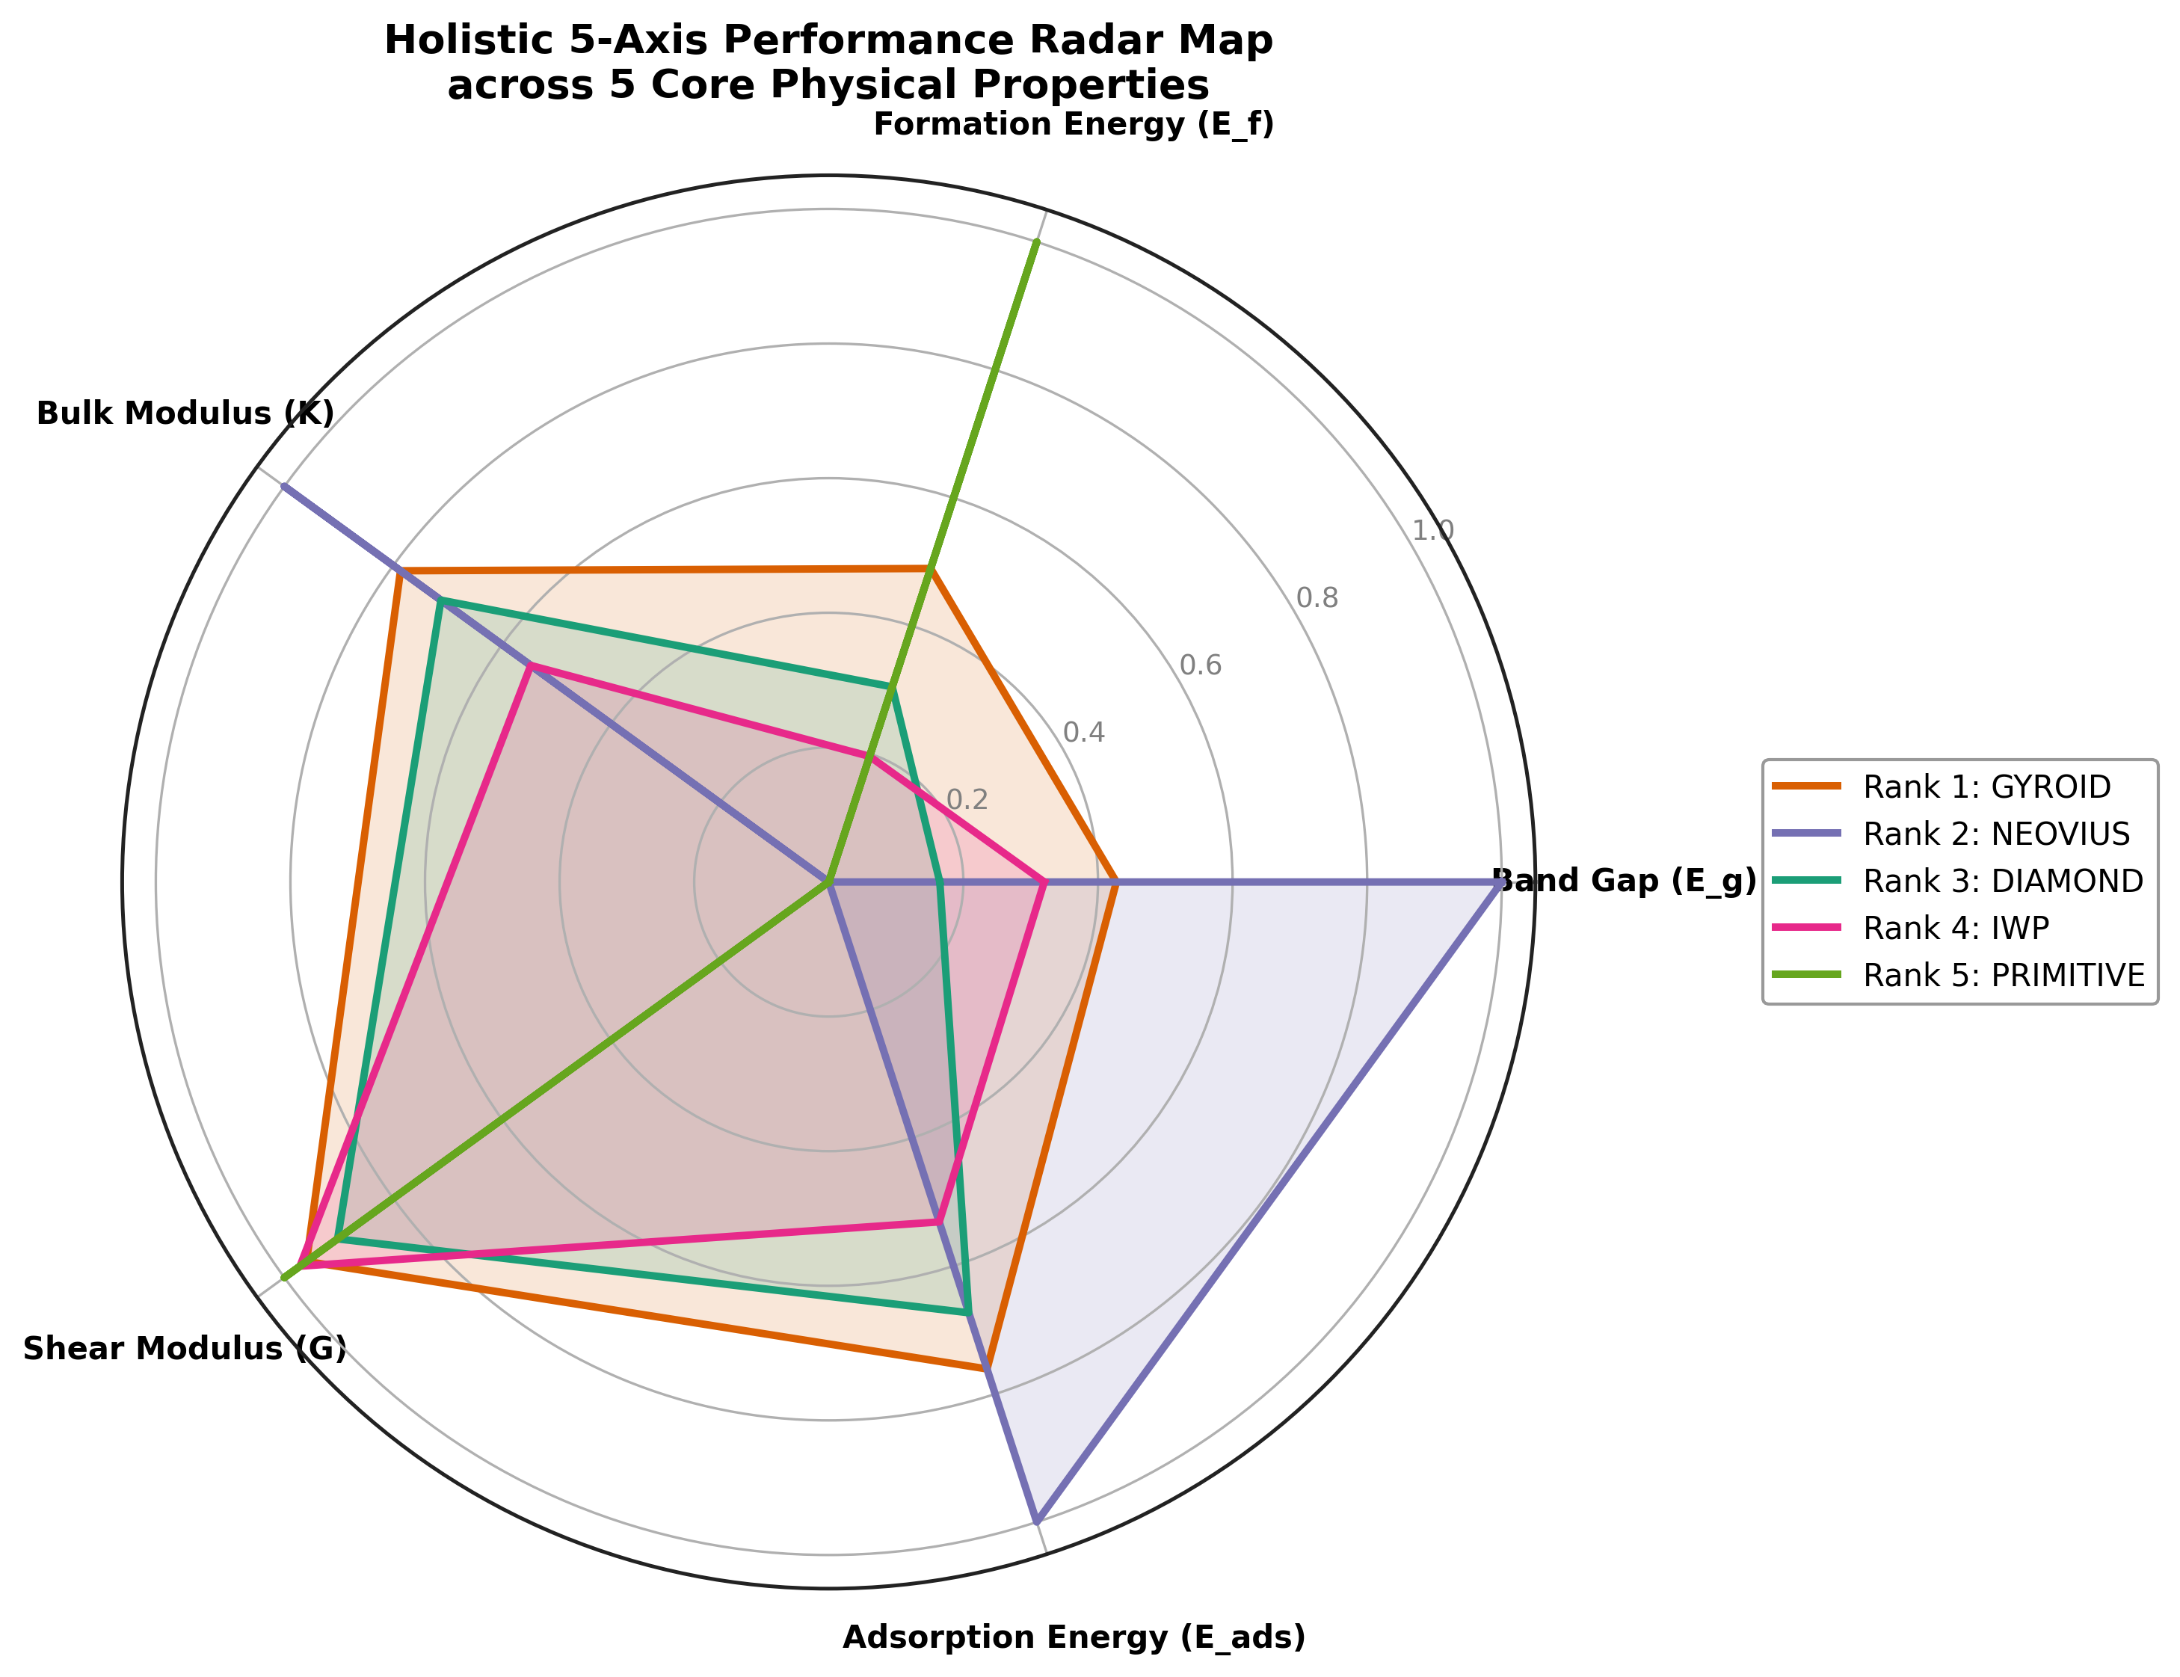

Figure 15 Top Five Materials Project candidates ranked according to the predicted Li–S host suitability score.

Conclusions
The crystalline material properties can be predicted simultaneously using the Crystal Graph Convolutional Neural Network, which serves as a screening method for LiSB cathode host materials. The properties tested in this model are band gap, formation energy, bulk modulus, and shear modulus. Across all four properties, CGCNN performance shows the highest prediction accuracy for band gap (R² = 0.9976, Pearson correlation = 0.9990), followed by formation energy (R² = 0.9965), bulk modulus (R² = 0.9890), and shear modulus (R² = 0.9823). The model learns effectively and generalizes well, with no indication of overfitting, as confirmed by the training, validation, and testing loss curves.
The validated model was used to screen materials for five graphene structures based on Triply Periodic Minimal Surfaces (TPMS). Among all TPMS types, Gyroid shows the highest score (0.68) across all properties, followed by Neovius, Diamond, IWP, and Primitive. This indicates that Gyroid is the most promising LISB cathode host due to its low band gap and good mechanical properties.
Overall, this study shows that CGCNN can assist DFT-based materials screening by rapidly predicting material properties and reducing the number of candidates that first-principles calculations must consider, given their high computational cost.
Acknowledgments
The authors received no specific funding for this work and declare no conflict of interest regarding the publication of this paper.

Data availability statement
The data that support the findings of this study are available from the corresponding author upon reasonable request.
Author contributions
Muhammad Amarus Salam (M.A.S): Data Curation, Investigation, Acquisition, Writing, Analysis.
Mauludi Ariesto Pamungkas (M.A.P): Conceptualisation, Formal Analysis, Methodology, Supervision, Investigation, Writing – Review & Editing.
Muhammad Hilmy Alfaruqi (M.H.A): Review & Editing, Supervision.

References
[1] F. M. N. U. Khan, M. G. Rasul, A. S. M. Sayem, and N. K. Mandal, “Design and optimization of lithium-ion battery as an efficient energy storage device for electric vehicles: A comprehensive review,” J. Energy Storage, vol. 71, p. 108033, Nov. 2023, doi: 10.1016/j.est.2023.108033.
[2] C.-D. Wei, H.-T. Xue, Q.-S. Zhao, Y.-X. Hu, and F.-L. Tang, “Uncovering the discharge structure evolution and electrochemical performance of sulfur cathode host 2D-Fe0.89M0.11S2 (M = Ti, V),” J. Energy Storage, vol. 87, p. 111419, May 2024, doi: 10.1016/j.est.2024.111419.
[3] A. Freitag, M. Stamm, and L. Ionov, “Separator for lithium-sulfur battery based on polymer blend membrane,” J. Power Sources, vol. 363, pp. 384–391, Sep. 2017, doi: 10.1016/j.jpowsour.2017.07.077.
[4] A. Narayan Singh and K.-W. Nam, “The rise of practical lithium-sulfur battery materials,” Chin. J. Catal., vol. 83, pp. 96–131, Apr. 2026, doi: 10.1016/S1872-2067(26)64968-6.
[5] M. Khan, “Inside lithium–sulfur batteries: Real-time multimodal insights into structure and polysulfide dynamics,” Energy Storage Mater., vol. 82, p. 104617, Oct. 2025, doi: 10.1016/j.ensm.2025.104617.
[6] U. M. Usman, A. K. Prajapati, A. Bhatnagar, and Shalu, “Cathode Design for High-Performance Li-S Batteries: A Brief Review,” ChemNanoMat, vol. 12, no. 1, 2026, doi: 10.1002/cnma.202500408.
[7] R. Mori, “Cathode materials for lithium-sulfur battery: a review,” J. Solid State Electrochem., vol. 27, no. 4, pp. 813–839, Apr. 2023, doi: 10.1007/s10008-023-05387-z.
[8] C.-C. Wu, Y.-C. Ho, and S.-H. Chung, “A low-self-discharge high-loading polysulfide cathode design for lithium-sulfur cells,” J. Mater. Chem. A, vol. 11, pp. 24651–24660, 2023, doi: 10.1039/D3TA05233A.
[9] W. Ren, W. Ma, S. Zhang, and B. Tang, “Recent advances in shuttle effect inhibition for lithium sulfur batteries,” Energy Storage Mater., vol. 23, pp. 707–732, Dec. 2019, doi: 10.1016/j.ensm.2019.02.022.
[10] S.-Y. Li, W.-P. Wang, H. Duan, and Y.-G. Guo, “Recent progress on confinement of polysulfides through physical and chemical methods,” J. Energy Chem., vol. 27, no. 6, pp. 1555–1565, Nov. 2018, doi: 10.1016/j.jechem.2018.04.014.
[11] K. Coke, M. J. Johnson, J. B. Robinson, A. J. E. Rettie, T. S. Miller, and P. R. Shearing, “Illuminating Polysulfide Distribution in Lithium Sulfur Batteries; Tracking Polysulfide Shuttle Using Operando Optical Fluorescence Microscopy,” ACS Appl. Mater. Interfaces, vol. 16, no. 16, pp. 20329–20340, Apr. 2024, doi: 10.1021/acsami.3c14612.
[12] A. Dorai, J. Kawamura, and T. Omata, “Visualization of polysulfide dissolution in lithium-sulfur batteries using in-situ NMR microimaging,” Electrochem. Commun., vol. 141, p. 107360, Aug. 2022, doi: 10.1016/j.elecom.2022.107360.
[13] S.-Y. Jung et al., “Low-polarity solvent-mediated lithium metal stabilization for improved performance in lithium–sulfur batteries,” J. Energy Chem., vol. 114, pp. 737–749, Mar. 2026, doi: 10.1016/j.jechem.2025.10.041.
[14] Z. Zhu, “Strategies for inhibiting the ‘shuttle effect’ in lithium-sulfur batteries: surface/interface modulation and bulk phase optimization,” Coord. Chem. Rev., vol. 548, p. 217220, Feb. 2026, doi: 10.1016/j.ccr.2025.217220.
[15] F. Zhou, “Bimetallic MOF-derived CNTs-grafted carbon nanocages as sulfur host for high-performance lithium–sulfur batteries,” Electrochimica Acta, vol. 349, p. 136378, Jul. 2020, doi: 10.1016/j.electacta.2020.136378.
[16] X. Geng, “Application of MXene-Based Materials for Cathode in Lithium-Sulfur Batteries,” Chem. - Eur. J., 2024, doi: 10.1002/chem.202303451.
[17] C. M. Costa, V. M. Macedo, M. Salado, L. C. Fernandes, M. Zhao, and S. Lanceros-Méndez, “An overview of solid-state lithium metal batteries: Materials, properties and challenges,” EnergyChem, vol. 7, no. 5, p. 100169, Sep. 2025, doi: 10.1016/j.enchem.2025.100169.
[18] X. Niu, “A study of the structure and performance enhancement of MgNb co-doped LiFePO4 based on first principles,” Chem. Phys., vol. 608, p. 113239, Sep. 2026, doi: 10.1016/j.chemphys.2026.113239.
[19] “Development of carbon materials for sulfur cathodes in inorganic-based solid-state lithium-sulfur batteries,” Can. J. Chem., 2023, doi: 10.1139/cjc-2023-0012.
[20] L. Mao, “Advances in the density functional theory (DFT) calculation of lithium-sulfur battery cathodes,” Mater. Today Commun., vol. 36, p. 106814, Aug. 2023, doi: 10.1016/j.mtcomm.2023.106814.
[21] D. Cai, “Design of coatings for sulfur-based cathode materials in lithium-sulfur batteries: a review,” Chem. - Asian J., 2024, doi: 10.1002/asia.202400099.
[22] L. Song, M. Zhang, X. Cao, and J. Guo, “VX (X = S, Se) as anchoring materials for lithium-sulfur batteries – A theoretical study,” Comput. Mater. Sci., vol. 210, p. 111040, Jul. 2022, doi: 10.1016/j.commatsci.2021.111040.
[23] X. Liu, “Design of disordered cathode hosts for lithium-sulfur batteries using two-dimensional sulfides,” Appl. Surf. Sci., vol. 688, p. 162338, Apr. 2025, doi: 10.1016/j.apsusc.2025.162338.
[24] V. Ragavendran, “Machine learning-accelerated discovery of battery electrode materials for sustainable energy storage: A critical survey of DFT descriptors, benchmarked models and experimentally validated predictions in support of SDG 7 and SDG 9,” Comput. Condens. Matter, vol. 48, p. e01410, Oct. 2026, doi: 10.1016/j.cocom.2026.e01410.
[25] G. Xu, “Machine learning-accelerated discovery and design of electrode materials and electrolytes for lithium ion batteries,” Energy Storage Mater., vol. 72, p. 103710, Sep. 2024, doi: 10.1016/j.ensm.2024.103710.
[26] T. Xu, “A machine learning-based crystal graph network and its application in development of functional materials,” Mater. Genome Eng. Adv., 2024, doi: 10.1002/mgea.38.
[27] S. Singh, P. Joshi, A. Sharma, and A. Kashyap, “A simple feature enriched CGCNN for predicting magnetization in transition metal compounds,” J. Magn. Magn. Mater., vol. 633, p. 173541, Nov. 2025, doi: 10.1016/j.jmmm.2025.173541.
[28] H. Wang, C. Zhao, W. Liu, Z. Liu, H. Bian, and K. Zhang, “Advances in triply periodic minimal surface structures for thermal management systems: a comprehensive review,” Appl. Therm. Eng., vol. 279, p. 127481, Nov. 2025, doi: 10.1016/j.applthermaleng.2025.127481.
[29] M. S. El-Asfoury, N. E. El-Bedwehy, M. Shazly, and A. Elkaseer, “Orientation driven design and mechanical optimization of gyroid TPMS lattice structures,” Sci. Rep., vol. 16, no. 1, p. 4373, Jan. 2026, doi: 10.1038/s41598-026-35201-5.
[30] M. S. Hossain, M. M. Hossain, and S. Nilufar, “An Overview of Additive Manufacturing of Triply Periodic Minimal Surface (TPMS) Structures,” Polymers, vol. 17, no. 24, p. 3307, Jan. 2025, doi: 10.3390/polym17243307.

